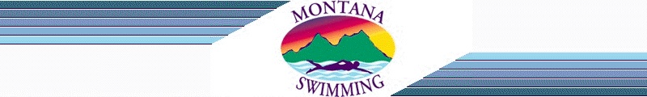
2017 Western Zone Coach for Team Montana Application

Name____________
Club______________
Age Group you coach ________________

Interested in coaching at: Age Group Zones - ________
Senior Zones - _________

This year we are looking for:

Up to two coaches to represent Team Montana at the Senior Zones Swim Meet in
Clovis, California, August 1-5

One coach to act as Assistant Coach at AG Zone Meet in Roseville, California, August

Applications need to be emailed to the Montana Swimming Chair and Vice Chair. Then they along with a panel will chose the coaches.

Please write a short essay response stating:

1. What is your reason for wanting to coach at the Western Zone Swim Meet?
2. How would MT swimmers benefit from you being one of the coaches?
3. What knowledge or skills set will you bring with you?
4. What do you hope to learn/achieve by being part of Team Montana?

Signature: ______________________ Date: __________________

